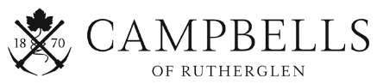

Vineyard Platter – Available all day, every day!

MILAWA CHEESES QTY
Milawa Aged Blue $8.00 ____
Milawa Brie $8.00 ____

ISLE OF MANN CREAMERY QTY
Vintage Cheddar $8.00 ____ Aged Red Leicester $8.00 ____
CHARCUTERIE Murray River Smokehouse Albury QTY
Pastrami $10.00 ____
Smoked trout fillet $10.00 ____
Terrine en croute $10.00 ____

ACCOMPANIMENTS QTY
Jim Jam Paste 60g Fig Quince $5.00 ____
Gooramadda Olives 60g $3.00 ____

BISCUITS, WAFERS, LAVOCHE QTY
Lavoche 150g $6.00 ____
Wafers 120g (Gluten Free) $6.00 ____
Miller’s Elements Fire, Earth, Ale Crackers 100g $7.00 ____
Fine Cheese Co. Crackers (assorted) 150g $8.00 ____

